SWE20004 Technical Software Development Semester 1 2019

Assignment 3 report

Name: Franz Tamani Student ID: 102114822

Lab class: Thurs / 4:30 / EN303 Tutor: Gavin Chan

Due Date: Monday 23th May 2019 at 11:59 pm

Date Submitted: Tuesday 18th May 2019 at 5:00pm

Assignment Title: 3

Program description

The program reads in employee details from a file, which is then stored into memory. The user can choose to display, sort or search the employee details. The program can also add in new information into the text file according to user input.

Inputs and Outputs
The inputs and outputs for this program are described in Table 1.

Table 1. Data dictionary:
Data to be stored | Sample data | Type of data | C++ type | Input method | In /  Out | Variable name
Input file stream | “pay.txt” | filestream | ifstream | open(),  >> | in | inFIle
Output file stream | “pay.txt” | Filestream | ofstream | open(),  << | out | outFile
Menu State | 0, 1, 5 | integer | int | cin | in | menuOption
Average salary | $150.5 | real number | float | cout | out | average
Employee Name | “John Smith” | Words | string | cin | in | empName
Largest Salary | $150.5 | real number | float | cout | out | largestSalary
Employee Details | “Franz, 102, $10” | Structure/ record | struct | cout | out | employeeArray;

Source code:
/*
Name: Franz Tamani
StuID: 102114822
Unit: SWE20004 - Technical Software Development
Summary: Reads an employee details from file
and stores them into memory.
The user can then sort and search
the information. The user can also
add new information which the program
adds into the text file, then reloads it.
*/

#include<iostream>
#include<string>
#include<fstream>
#include<iomanip>

using namespace std;

struct employee {
string name;
int id;
float salary;
};

int readFile(employee *emp, ifstream * inFile)
{
inFile->open("pay.txt");

if (inFile->fail())
{
cout << "Input File - ERROR!!!" << endl;
exit(1); //1 - define input file error
}

int i = 0;
while (!inFile->eof())
{
string fName;
string lName;
*inFile >> fName >> lName >> emp[i].id >> emp[i].salary;
emp[i].name = fName + " " + lName;
i++;
}
//Closes file
inFile->close();
//Subtract i because we added to it above, even though end of file was reached.
return --i;
}

int menu()
{
int input = 0;
cout << "Please Choose a Number" << endl;
cout << "1. Display Employees' Details" << endl;
cout << "2. Calculate Average for All Employees' Salaries" << endl;
cout << "3. Sort Employees Details" << endl;
cout << "4. Search for a Particular Employees Salary" << endl;
cout << "5. Find Maximum Salary" << endl;
cout << "6. Add New Employee to Record" << endl;
cout << "7. Quit Program" << endl;

cin >> input;

return input;
}

void displayEmployees(employee emp[], int size)
{
cout << "----------------------------------------------------------------------------------------------------" << endl;
cout << setw(50) << "Employees" << endl;
cout << "----------------------------------------------------------------------------------------------------" << endl;
cout << "ID\t" << setw(30) << "Employee Name" << setw(40) << "Salary" << endl;
cout << "----------------------------------------------------------------------------------------------------" << endl;
for (int i = 0; i < size; i++)
{
cout << emp[i].id << "\t" << setw(30);
cout << emp[i].name << setw(40);
cout << fixed << setprecision(2) << emp[i].salary << endl;
}
cout << "----------------------------------------------------------------------------------------------------" << endl;
}

float calculateAverage(employee emp[], int size)
{
float total = 0;
for (int i = 0; i < size; i++)
{
total += emp[i].salary;
}
//cout << "The total is: " << total << endl;
return total / size; //Calculates and Returns Average
}

void sortByName(employee emp[], int size)
{
for (int i = size - 1; i > 0; i--)
{
for (int j = 0; j < i; j++)
{
//Checks first letters
if (emp[j].name > emp[j + 1].name)
{
swap(emp[j], emp[j + 1]);
}
}
}
}

void sortBySalary(employee emp[], int size)
{
for (int i = size - 1; i > 0; i--)
{
for (int j = 0; j < i; j++)
{
if (emp[j].salary > emp[j + 1].salary)
{
swap(emp[j], emp[j + 1]);
}
}
}
}

int binarySearch(employee emp[], int start, int last, string name)
{
//Algorithm sourced from https://www.geeksforgeeks.org/binary-search/
if (last >= start) {
int mid = last + (start - last) / 2;

// If the element is present at the middle
// itself
if (emp[mid].name == name)
return mid;

// If element is smaller than mid, then
// it can only be present in left subarray
if (emp[mid].name > name)
return binarySearch(emp, start, mid - 1, name);

// Else the element can only be present
// in right subarray
return binarySearch(emp, mid + 1, last, name);
}

// Element is not present in the array
return -1;
}

int findEmployeeSalary(employee emp[], int size, string name)
{
int input;
bool leave = false;
int start = 0, mid = size / 2, end = size;
while (!leave)
{
cout << "Would you like to do: 1. Linear Search 2. Binary Search 0. Cancel" << endl;
cin >> input;
switch (input)
{
default:
cin.clear();
cin.ignore(numeric_limits<streamsize>::max(), '\n');
cout << "That is not a valid entry, try again" << endl;
break;
case 1:
for (int i = 0; i < size; i++)
{
if (emp[i].name == name)
return i;
}
return -1;
break;
case 2:
//Need to sort as Binary Search only works on sorted array
sortByName(emp, size);
return binarySearch(emp, start, size, name);
break;
case 0:
return -2;
break;
}
}
}

float findMaximum(employee emp[], int size)
{
//Sorts the Salary and gets the last value as
//Array is sorted lowest to highest.
sortBySalary(emp, size);

return emp[size - 1].salary;
}

//Cannot pass ofstream for some reason
//Says it is a deleted function on tool tip
void updateFile(ofstream * outFile)
{
string name;
int id;
float salary;

outFile->open("pay.txt", std::ios::app);

if (outFile->fail())
{
cout << "Output File - ERROR!!!" << endl;
exit(2); //2 - define input file error
}

cout << "Enter Employee Name: " << endl;
cin.clear();
cin.ignore();
getline(cin, name);
cout << "Enter Employee ID: " << endl;
cin >> id;
cout << "Enter Salary: " << endl;
cin >> salary;
*outFile << endl << name << " " << id << " " << salary << endl;
outFile->close();
}

int main()
{
employee employeeArray[100];
ifstream inFile;
ofstream outFile;
int arraySize, index;
float average, largestSalary;
string empName;
bool leave = false;

cout << "Welcome, This Application is Used to Manage Employee Details" << endl;

arraySize = readFile(employeeArray, &inFile);

while (!leave)
{
int menuOption = 0;
menuOption = menu();
switch (menuOption)
{
case 1:
//Prints Employees on console
displayEmployees(employeeArray, arraySize);
break;
case 2:
//Find Average Salary
average = calculateAverage(employeeArray, arraySize);
cout << "The Average Salary is: " << fixed << setprecision(2) << average << endl;
break;
case 3:
//Sort Employees
cout << "Sort Employees By: 1. Name, 2. Salary" << endl;
cin >> menuOption;
switch (menuOption)
{
case 1:
sortByName(employeeArray, arraySize);
cout << "List Has Been Sorted A-Z" << endl;
break;
case 2:
sortBySalary(employeeArray, arraySize);
cout << "List Has Been Sorted Low-High" << endl;
break;
default:
cin.clear();
cin.ignore(numeric_limits<streamsize>::max(), '\n');
cout << "That is not a valid entry, try again" << endl;
break;
}
break;
case 4:
cout << "Enter Employee Name:" << endl;
//Ignores new lines entered from old input (enter key)
cin.clear();
cin.ignore();
getline(cin, empName);
index = findEmployeeSalary(employeeArray, arraySize, empName);
if (index >= 0)
{
cout << "Employee Name: " << employeeArray[index].name << endl;
cout << "Employee ID: " << employeeArray[index].id << endl;
cout << "Salary: $" << employeeArray[index].salary << endl;
}
else if (index == -1)
{
cout << "Cannot Find Employee" << endl;
}
menuOption = 0;
break;
case 5:
//Finds Largest Salary
largestSalary = findMaximum(employeeArray, arraySize);
cout << "The Largest Salary is: $" << largestSalary << endl;
break;
case 6:
//Enter New Employee
updateFile(&outFile);
arraySize = readFile(employeeArray, &inFile);
break;
case 7:
return 0;
break;
default:
//Clears failed cin.
cin.clear();
cin.ignore(numeric_limits<streamsize>::max(), '\n');
cout << "That is not a valid entry, try again" << endl;
break;
}
}
}

Screenshots showing working program (Show all possible outcome):
Display All Employees
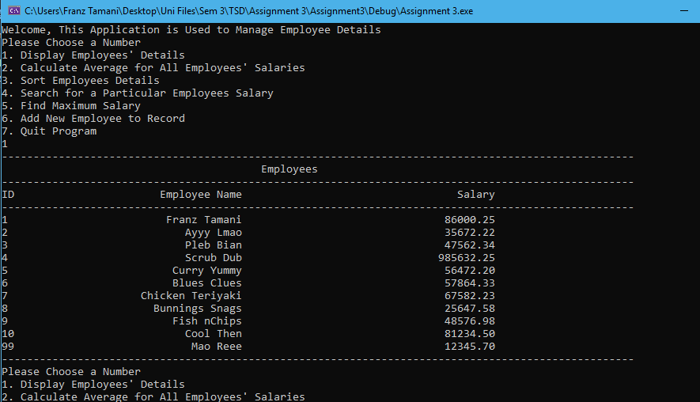
Find Average Salary
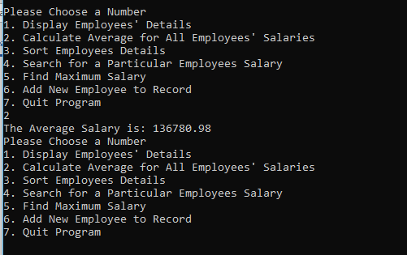

Sort By Name
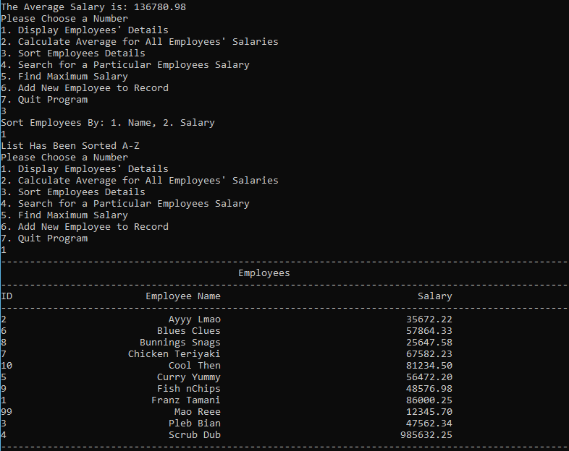
Sort By Salary
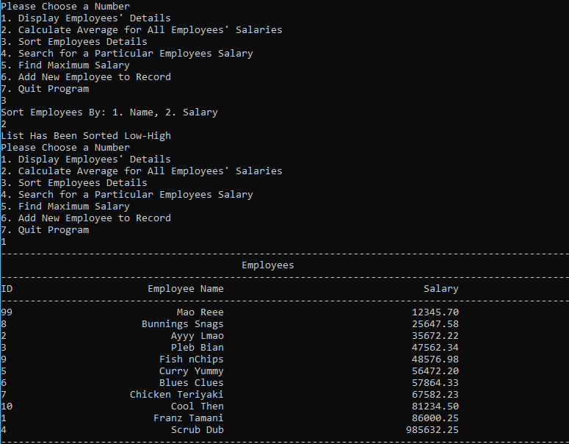

Search For Employee Salary with Linear Search
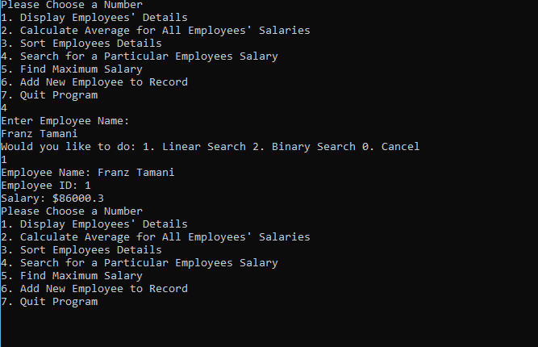
Search For Employee Salary with Binary Search
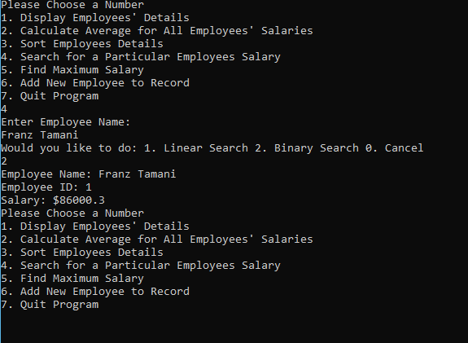

Find Maximum Salary
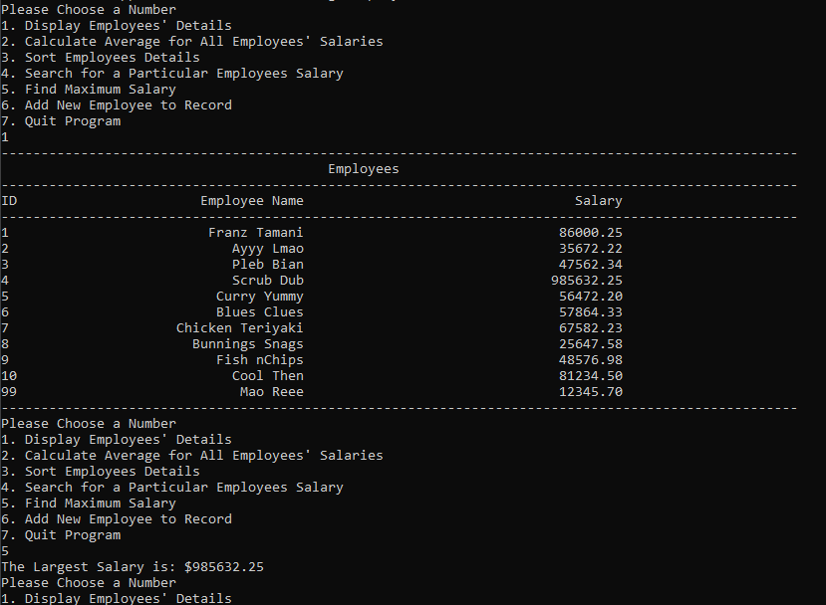

Add New Employee to Record 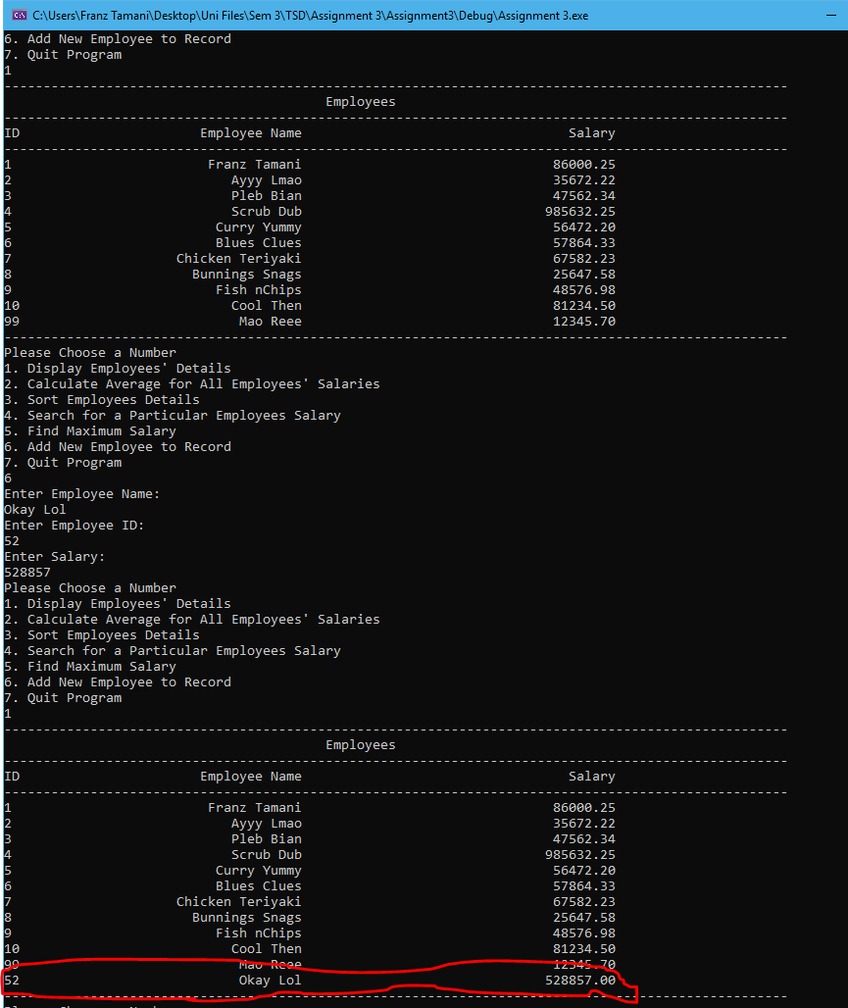

Exit Program
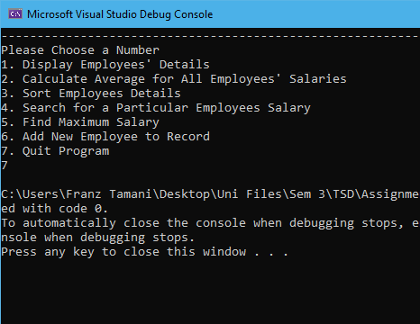

Task 8.5

Program description

The program reads from a file to find the minimum, maximum, average and total costs of items from a file. It then outputs them onto another file.

Source Code

/*
Name: Franz Tamani
StuID: 102114822
Unit: SWE20004 - Technical Software Development
Summary: Reads from a file to find minimum,
maximum, total and average pricing
and writes it to a file.
*/
#include <iostream>
#include <fstream>
#include <string>

using namespace std;

int main()
{
ifstream inFile; //input file price.dat
ofstream outFile; //output file output.dat
inFile.open("price.dat");

if (inFile.fail())
{
cout << "Input File - ERROR!!!" << endl;
exit(1); //1 - define input file error
}

int count, i;
double id, price, max, min, avg, total;

inFile >> count;
for (i = 0; i < count; i++)
{
inFile >> id >> price;
if (i == 0)
total = min = max = price;
if (price > max)
max = price;
if (price < min)
min = price;

total += price;
}
inFile.close(); //Closes input file

outFile.open("output.dat");

if (outFile.fail())
{
cout << "Output File - ERROR!!!" << endl;
exit(2); //2 - define output file error
}

avg = (total / count);

outFile << "Number of price readings: " << count << endl;
outFile << "Maximum price: " << max << endl;
outFile << "Minimum price: " << min << endl;
outFile << "Average price: " << avg << endl;
outFile.close(); //Closes output file

return 0;
}

Screenshots showing working program
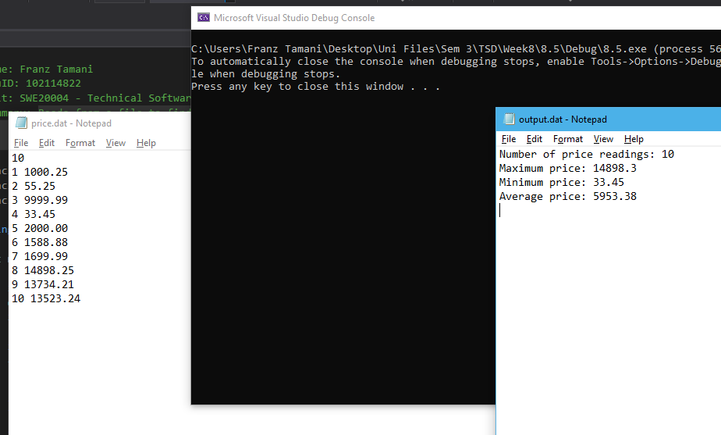

Task 8.6

Program description

Reorders 3 given numbers in ascending order.

Source Code

/*
Name: Franz Tamani
StuID: 102114822
Unit: SWE20004 - Technical Software Development
Summary: Reorders 3 given numbers in ascending order.
*/
#include <iostream>

using namespace std;

void reorder(int *a, int *b, int *c)
{
int temp; //used for ordering numbers
//Orders numbers from left to right
if (*a > *b)
{
temp = *a;
*a = *b;
*b = temp;
}
if (*b > *c)
{
temp = *b;
*b = *c;
*c = temp;
}

//Orders numbers from right to left.
if (*c < *b)
{
temp = *b;
*b = *c;
*c = temp;
}
if (*b < *a)
{
temp = *b;
*b = *a;
*a = temp;
}
}

int main()
{
while (!cin.fail())
{
int arr[3]; //used to store and print numbers.
//Asks the user to input data
cout << "Enter 3 Numbers" << endl;
for (int i = 0; i < 3; i++)
{
cin >> arr[i];
}

//Prints numbers in original order
cout << "\nOriginal Number: ";
for (int i = 0; i < 3; i++)
{
cout << arr[i] << " ";
}

//Reorders the numbers
reorder(&arr[0], &arr[1], &arr[2]);

//Prints numbers after reordering them
cout << "\n\nReordered Number: ";
for (int i = 0; i < 3; i++)
{
cout << arr[i] << " ";
}
}
return 0;
}

Screenshots showing working program
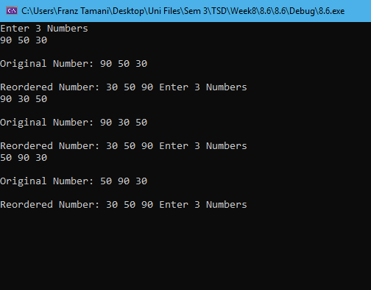

Task 9.2

Program description
The program gets employee details from use, the user can then get employee and company details using their names.

Source Code
/*
Name: Franz Tamani
StuID: 102114822
Unit: SWE20004 - Technical Software Development
Summary: The program gets employee info from user.
User can then get employee and company
details using their names.
*/

#include<iostream>
#include<string>
#include<iomanip>

using namespace std;

#define SIZE 5

struct Emp get_data();
void print_data(struct Emp[], int);
double get_average(struct Emp*, int, string);
double get_salary(struct Emp[], string);

struct company_detail
{
string company_id;
string company_name;
};
struct Emp
{
string emp_name;
string emp_id;
double salary;
struct company_detail cmp_detail;
};

int main()
{
Emp employee[SIZE];
int entries;
double salary;
string name;

cout << "How many employees do you want to enter?" << endl;
cin >> entries;
cin.ignore();

for (int i = 0; i < entries; i++)
{
employee[i] = get_data();
}

print_data(employee, entries);

cout << "Type Employee Name to Get Salary" << endl;
getline(cin, name);
salary = get_salary(employee, name);
if (salary != 0)
{
cout << "Salary for " << name << " is $" << salary << endl;
}
else
{
cout << "Employee could not be found" << endl;
}

cout << "Enter Company Name to Find Average Salary" << endl;
cin >> name;
salary = get_average(employee, entries, name);
if (salary != 0)
{
cout << "Average Salary for " << name << " is $" << setprecision(10) << salary << endl;
}
else
{
cout << "Company Could Not Be Found" << endl;
}
return 0;
}

struct Emp get_data()
{
Emp result;

cout << "Enter Employee Name" << endl;
getline(cin, result.emp_name);
cout << "Enter Employee ID" << endl;
cin >> result.emp_id;
cout << "Enter Salary" << endl;
cin >> result.salary;
cout << "Enter Company ID" << endl;
cin >> result.cmp_detail.company_id;
cout << "Enter Company Name" << endl;
cin.ignore();
getline(cin, result.cmp_detail.company_name);

return result;
}

void print_data(Emp employee[], int entries)
{
for (int i = 0; i < entries; i++)
{
cout << "\nEntry Number: " << i + 1 << endl;
cout << "Employee Name: " << employee[i].emp_name << endl;
cout << "Employee ID: " << employee[i].emp_id << endl;
cout << "Salary: " << employee[i].salary << endl;
cout << "Company ID: " << employee[i].cmp_detail.company_id << endl;
cout << "Company Name: " << employee[i].cmp_detail.company_name << endl;
}
}

double get_salary(Emp employee[], string name)
{
for (int i = 0; i < SIZE; i++)
{
if (employee[i].emp_name == name)
return employee[i].salary;
}
return 0;
}

double get_average(Emp * employee, int entries, string name)
{
double result = 0;
int count = 0;

for (int i = 0; i < entries; i++, employee++)
{
if (employee->cmp_detail.company_name == name)
{
result += employee->salary;
}
count++;
}
return result/count;
}

Screenshots showing working program

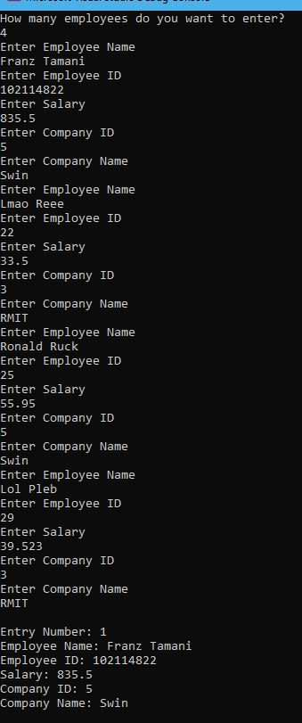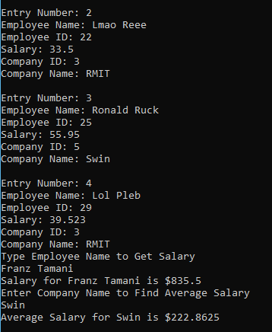

Task 9.3

Program description
The program takes album details from user and allows them to display them onto the console. It also allows the user to select a song to play.

Source Code

/*
Name: Franz Tamani
StuID: 102114822
Unit: SWE20004 - Technical Software Development
Summary: The program takes album details from
user and allows them to play music.
*/

#include<iostream>
#include<string>
#include<list>
#include<vector>

#pragma comment(lib, "winmm.lib")

using namespace std;

enum genre { Jap, Eng, Other };

struct album
{
string albName;
genre type;
int trackAmt;
string tracks[5];
string trackLoc;
};

void add_album(vector<album> &albList)
{
string name, track, loc;
int type, amtTrack;
album alb;

cout << "\nEnter Album Name: ";
cin >> name;
alb.albName = name;
cout << "Enter Genre: 1. Jap, 2. Eng, 3. Other: ";
cin >> type;
//Sets genre accordingly
switch (type)
{
case 1:
alb.type = Jap;
break;
case 2:
alb.type = Eng;
break;
default:
alb.type = Other;
break;
}
//Get user to enter tracks
cout << "Enter Number of Tracks 1-5: ";
cin >> amtTrack;
//Add amount of tracks to the struct
alb.trackAmt = amtTrack;
cout << "Enter the Name of These " << amtTrack << " Tracks" << endl;
for (int i = 0; i < amtTrack; i++)
{
cin.clear();
cin.ignore();
//getline(cin, track);
cin >> track;
alb.tracks[i] = track;
}
//Get user to enter file loc
cout << "Enter File Location for These Tracks" << endl;
cin >> loc;
alb.trackLoc = loc;
//Adds Album to list
albList.push_back(alb);
//creates a new line, to make console more readable
cout << endl;
}

void print_all_album(vector<album> &albList)
{
string gen[3] = { "Jap", "Eng", "Other" };
for (auto a : albList)
{
cout << "\nName of Album: " << a.albName << endl;
cout << "Genre of Album: " << gen[a.type] << endl;
cout << "Tracks in Album:" << endl;
for (int i = 0; i < a.trackAmt; i++)
{
cout << a.tracks[i] << endl;
}
cout << "Tracks are Located at: " << a.trackLoc << endl << endl;
}
}

void select_track_to_play(vector<album> &albList)
{
string name, command;
album alb;
int trackNum;

cout << "Select an Album to Play: ";
cin >> name;
for (auto a : albList)
{
if (a.albName == name)
alb = a;
}
cout << "This Album has " << alb.trackAmt << " Tracks:" << endl;
for (int i = 0; i < alb.trackAmt; i++)
{
cout << i + 1 << ". " << alb.tracks[i] << endl;
}
cout << "Select Track to Play 1 to " << alb.trackAmt << ": ";
cin >> trackNum; //Just reusing variable;
//Array index starts at 0, we added +1 above, so we subtract 1
cout << "Track: " << alb.tracks[trackNum - 1] << " from Album: " << alb.albName
<< " is Now Playing from " << alb.trackLoc << endl << endl;
command = "start wmplayer.exe -p C:\\" + alb.trackLoc + "\\" + alb.tracks[trackNum - 1] + ".mp3";
system(command.c_str());
}

int main()
{
vector<album> albList;
bool exit = false;
string command;
int trackNum;
unsigned int choice = 0;

while (!exit)
{
switch (choice)
{
//Main Menu
case 0:
cout << "Choose an Option:" << endl;
cout << "1. Add an Album" << endl;
cout << "2. Print Album Details" << endl;
cout << "3. Play Track From an Album" << endl;
cout << "4. Exit" << endl;
cin >> choice;
break;
//Enter New Album
case 1:
add_album(albList);
choice = 0; //back to menu when finished
break;
//Print Album Details
case 2:
print_all_album(albList);
choice = 0; //back to menu when finished
break;
//Play Selected Song
case 3:
select_track_to_play(albList);
choice = 0; //back to menu when finished
break;
//Exit Application
case 4:
exit = true;
break;
//Used for errors when inputting choice
default:
choice = 0;
cin.clear();
cin.ignore(numeric_limits<streamsize>::max(), '\n');
cout << "Invalid Input!!!" << endl;
break;
}
}
return 0;
}

Screenshots showing working program
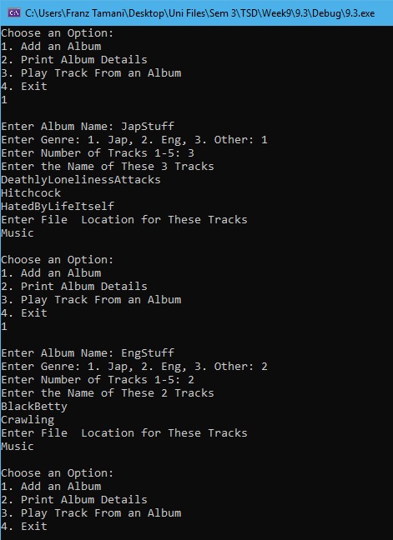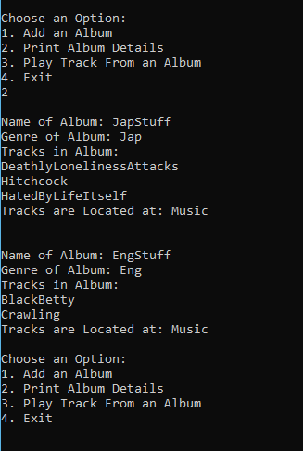
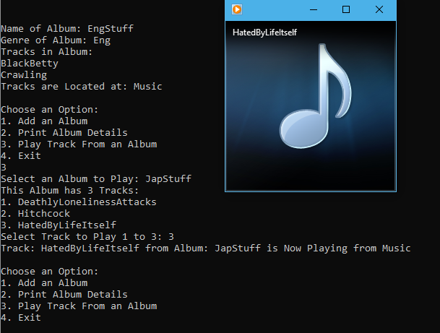

Task 10.2

Program description
The program creates 5 studentname structs and stores them into a linked list in alphabetical order, it then outputs them.

Source Code
/*
Name: Franz Tamani
StuID: 102114822
Unit: SWE20004 - Technical Software Development
Summary: The program creates 5 studentname structs
and stores them in a linked in alphabetical
order, it then prints them.
*/
#include<iostream>

using namespace std;

struct studentname
{
char letter;
struct studentname* next;
};

typedef struct studentname STUDENTName;
typedef STUDENTName* STUDENTNamePtr;

int main()
{
STUDENTNamePtr s1 = new STUDENTName;
STUDENTNamePtr s2 = new STUDENTName;
STUDENTNamePtr s3 = new STUDENTName;
STUDENTNamePtr s4 = new STUDENTName;
STUDENTNamePtr s5 = new STUDENTName;
s1->letter = 'T';
s2->letter = 'a';
s3->letter = 'm';
s4->letter = 'a';
s5->letter = 'n';

s2->next = s4;
s4->next = s3;
s3->next = s5;
s5->next = s1;
s1->next = NULL;

STUDENTNamePtr current = s2;
while (current != NULL)
{
cout << current->letter;
if (current->next != NULL)
cout << " -> ";
current = current->next;
}
return 0;
}

Screenshots showing working program
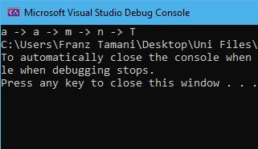

Task 10.3

Program description
The program generates 10 random numbers out of 50 and inserts each number in the linked list in ascending order.

Source Code
/*
Name: Franz Tamani
StuID: 102114822
Unit: SWE20004 - Technical Software Development
Summary: The program generates 10 random numbers
out of 50 and inserts each number in
the linked list in ascending order.
*/
#include<iostream>
#include<stdlib.h>
#include<time.h>

using namespace std;

struct numbers
{
int num;
struct numbers* next;
};

typedef struct numbers NUMBERS;
typedef NUMBERS* NUMBERSPtr;

float calcAvg(NUMBERSPtr current)
{
float total = 0;
int elements = 0;
while (current != NULL)
{
total += current->num;
current = current->next;
elements++;
}
return total / elements;
}

int main()
{
int num = 0;

srand(time(0));

NUMBERSPtr start = new NUMBERS;
NUMBERSPtr current = new NUMBERS;
NUMBERSPtr prev = new NUMBERS;
for (int i = 0; i < 10; i++)
{
num = rand() % 50 + 1;

cout << num << endl;

NUMBERSPtr newPtr = new NUMBERS;
newPtr->num = num;
newPtr->next = NULL;

if (i == 0)
{
start = newPtr;
}
else
{
//Inserts number in Linked List in sorted order
current = start;
prev = NULL;
while (current != NULL)
{
//Number is lower
if (newPtr->num < current->num)
{
//Lowest Number
if (prev == NULL)
{
//New Starting Position
start = newPtr;
newPtr->next = current;
break;
}
else
{
//Put new value before current value
prev->next = newPtr;
newPtr->next = current;
break;
}
}
else if (newPtr->num == current->num)
{
//If number is same as last number
if (current->next == NULL)
{
current->next = newPtr;
}
else
{
//Put new value in front of current value
newPtr->next = current->next;
current->next = newPtr;
}
break;
}
else if (newPtr->num > current->num)
{
//Largest Number
if (current->next == NULL)
{
current->next = newPtr;
break;
}
}
prev = current;
current = current->next;
}
}
}

current = start;
cout << "Now Printing All List Values" << endl;
int i = 0;
while (current != NULL)
{
cout << current->num;
if (current->next != NULL)
cout << " -> ";
current = current->next;
i++;
}
cout << endl << i << " Values have been printed" << endl;

cout << "The Average of all values are: " << calcAvg(start) << endl;
return 0;
}

Screenshots showing working program
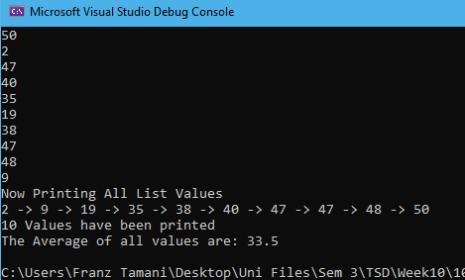

Task 10.4

Program description
The program determines whether a given word by the user is a palindrome or not by comparing a stack and a string.

Source Code
/*
Name: Franz Tamani
StuID: 102114822
Unit: SWE20004 - Technical Software Development
Summary: The program determines whether a word input
by user is a palindrome or not, by comparing
the values a stack, and the string.
*/
#include<iostream>
#include<string>

using namespace std;

struct Pal
{
char letter;
struct Pal* next;
};

typedef struct Pal Palindrome;
typedef Palindrome* palPtr;

int main()
{
palPtr stack1 = NULL;
palPtr stack2 = NULL;
string word;
bool palindrome = true;

cout << "Enter a word, no spaces, no caps." << endl;
cin >> word;

//Inserts the word into a stack
for (unsigned int i = 0; i < word.size(); i++)
{
palPtr newPtr = new Palindrome;
newPtr->letter = word[i];
//Push
newPtr->next = stack1; //Set old top as next
stack1 = newPtr; //Set newPtr as top;
}

//Compares stack with letters in a string to determine wether word is
//a palindrome or not.
for (unsigned int i = 0; i < word.size(); i++)
{
//Compares 2 letters, if they are the same move to the next letter.
if (stack1->letter == word[i])
{
//Pop
stack1 = stack1->next;
}
//If any of the letters do not match, it is not a palindrome
else
{
palindrome = false;
break;
}
}

if (palindrome)
{
cout << "The Word is a Palindrome" << endl;
}
else
{
cout << "The Word is not a Palindrome" << endl;
}
return 0;
}

Screenshots showing working program
